2019-1291

United States Court of Appeals
for the Federal Circuit
SMART METER TECHNOLOGIES INC.,
Appellant
v.
ITRON, INC.
Appellee.
Appeal from the United States Patent and Trademark Office,
Patent Trial and Appeal Board in No. IPR2017-01199

APPELLANT’S BRIEF
FILED ON BEHALF OF: APPELLANT, Smart Meter Technologies INC.
[[[signature block]]]
Counsel for Appellant

CERTIFICATE OF INTEREST AND CORPORATE DISCLOSURE
STATEMENT
Date: April 22, 2019
/s/ Decker A. Cammack
Decker A. Cammack
Counsel for Appellant
ii

TABLE OF CONTENTS
CERTIFICATE OF INTEREST AND CORPORATE DISCLOSURE
STATEMENT
TABLE OF CONTENTS
TABLE OF AUTHORITIES
- STATEMENT OF RELATED CASES
- JURISDICTIONAL STATEMENT
- STATEMENT OF ISSUES PRESENTED FOR REVIEW
- STATEMENT OF THE CASE
V. SUMMARY OF THE ARGUMENT
VI. ARGUMENT
VII. CONCLUSION
IX. PROOF OF SERVICE
X. CERTIFICATE OF COMPLIANCE

TABLE OF AUTHORITIES
CASES

STATUTES

REGULATIONS
OTHER AUTHORITIES

- STATEMENT OF RELATED CASES
There are no other appeals in or from the proceedings below that were previously before this or any other appellate court. U.S. Pat. No. 7,058,524 (the “’524 patent”), which is the subject of this appeal, is also at issue in Smart Meter Technologies Inc. v. Duke Energy Corporation, Case No. 1:16-cv-000208 (D. Del.), currently stayed.
- JURISDICTIONAL STATEMENT
This is an appeal under 35 U.S.C. § 141(c) of a Final Written Decision of the United States Patent and Trademark Office (“USPTO”) Patent Trial and Appeal Board (“Board”) under 35 U.S.C. § 318(a) in Case No. IPR2017-01199, finding claims 17 - 22 of the ’524 patent, unpatentable. Patent Owner, Smart Meter Technologies Inc. (“Smart Meter”), timely filed and served its Notice of Appeal within the sixty-three-day period established by 37 C.F.R. § 90.3(a) on December 10, 2018. The Board had jurisdiction over the matters below under 35 U.S.C. § 6(c), and this Court has sole jurisdiction over this appeal under 28 U.S.C. § 1295(a)4(A) and 35 U.S.C. § 141(c).
- STATEMENT OF ISSUES PRESENTED FOR REVIEW
The Board concluded that claims 17 - 22 of the ’524 patent were unpatentable under 35 U.S.C. § 103(a) in view of Suh, et al. (U.S. Patent App. Pub. No. 2002/0161536 A1 (Published Oct. 31, 2002) (Ex. 1006, Suh, APPX0910 – APPX0920) (“Suh”). In doing so, the Board determined that the level of ordinary skill in the art was the same level of skill needed to produce the claimed invention, and, further, that a person possessing such skill would find the invention obvious despite testimony from Itron’s expert, Dr. Akl, to the contrary, and despite failing to completely construe the only limitation of the claim at issue in the proceeding. The questions presented for this Court are whether the Board erred in its approach to resolving the issue of claims 17 - 22’s nonobviousness and its ultimate determination thereof, including whether the Board erred in declining to construe the limitation “autonomously in IP format over an external power line network.”
- STATEMENT OF THE CASE
The ’524 Patent relates generally to measuring and reporting consumption of electrical power at a metered site, such as a home or dwelling and reporting those measurements over a network. APPX0435 (The ’524 Patent, 1:5-11). The patent also discloses converting power consumption measurements into IP format. Id. In addition to disclosing and claiming transmission of the IP formatted consumption data via wireless networks and traditional telephone modem connection, the ’524 Patent in claims 17 – 22 recite transmission of the IP formatted consumption data over an external power line network. APPX0439.
For purposes of this appeal, Patent Owner only challenges the Board’s determination that a person of ordinary skill in the relevant art would have found the invention recited in claim 17 obvious over Suh. Specifically, that the last limitation of claim 17 would have been obvious in view of Suh: “transmitting the IP-based power consumption information from the processor to a destination autonomously in IP format over an external power line network.” APPX0439 (The ’524 Patent, 10:57-59).
In its Final Written Decision, the Board went out of its way to determine that Suh provided the necessary teachings to render the ’524 Patent obvious. Doing so required the Board to completely disregard the file history of the ’524 Patent, the teachings of Suh, and contradictions that Petitioner’s expert, Dr. Akl, propounded, while simultaneously choosing to disregard Patent Owner’s arguments and expert testimony as inconvenient truths.
The Board determined that claims 17 – 22 of the ’524 Patent would have been obvious to one of ordinary skill in the art at the time of the invention despite Petitioner’s expert’s testimony failing to identify a single teaching of a mechanism for sending IP-formatted data over an external power line network other than the ’524 Patent itself. The Board erred by ignoring this admission, choosing instead to simply discredit the Patent Owner’s arguments by citing law that is both inapposite and inapplicable to the this single-reference case. APPX0031-0032 (“The test for obviousness is not whether the features of a secondary reference may be bodily incorporated into the structure of the primary reference.”) (quoting “Allied Erecting & Dismantling Co. v. Genesis Attachments, LLC, 825 F.3d 1373, 1381 (Fed. Cir. 2016)). In the present case, there is no “secondary reference.”
The board also erred by ignoring Dr. Akl’s testimony that directly contradicted Petitioner’s arguments, and by combining admitted prior art references that teach away from transmitting data on an external power line network with Suh to arrive at its desired conclusion. When faced with a substantially identical argument from the patent examiner, the Patent Owner amended what is now claim 17 to add “autonomously in IP format over an external power line network.” APPX0658-0659. Delsing (Exhibit 1014), one of the references cited by the examiner against claim 17, explicitly discloses the use of a “power line modem.” APPX1131 (Fig. 1). However, consistent with the improperly disregarded testimony of Mr. Blackburn, the mere existence of a power line modem on the internal side of a dwelling does not teach transmission of IP formatted data over an external power line network, and the examiner allowed claim 17. APPX0671. Petitioner’s expert, Dr. Akl, confirms this portion of the prosecution history. APPX0738-0739 (¶¶58 – 61). Significantly, Dr. Akl cited the portion of the patentee’s ultimately prevailing argument that “the internal interface taught by Roos may include the internal power line but does not teach communicating by external power line….” Id. (¶59). Suh likewise does not teach the use of an external power line for communication.
It is hornbook law that a fact finder must make three inquiries when assessing the nonobviousness of a patent claim: (1) a determination of the scope and content of the prior art; (2) an assessment of the differences between the claimed invention and the prior art; and (3) a resolution of the level of ordinary skill in the art. Graham v. John Deere Co. of Kansas City, 383 U.S. 1, 17-18 (1966). Through consideration of these issues, the fact finder then decides whether a person of ordinary skill would have arrived at the claimed invention. Id. This analysis fails, however, where, as in the instant case, the Board credits uncorroborated rhetoric by an expert to arrive at the claimed invention. By ignoring the plain teachings of the prior art and the testimony before it, the Board arrived at its predetermined outcome of the obviousness inquiry in a legally impermissible way.
With respect to the first inquiry, the scope and content of the prior art applied by the Board begins and ends with Suh. This is important, because both the X.10 and HomePlug references were admitted as prior art in the specification, yet the Board erroneously used them to supply the teachings that Suh failed to disclose. “It is impermissible within the framework of section 103 to pick and choose from any one reference only so much it as will support a given position to the exclusion of other parts necessary to the full appreciation of what such reference fairly suggests to one skilled in the art.” Bausch & Lomb, Inc. v. Barnes-Hind/Hydrocurve, In., 796 F.2d 443, 448 (Fed. Cir. 1986); Charles v. Hedges, 783 F.2d 1038, 1041 (Fed. Cir. 1986). With respect to the third inquiry, the parties generally agree on the level of ordinary skill, which is not at issue in this case. The primary issue is, therefore, the application of the single prior art reference to claims 17-22 of the ’524 Patent. In this case, the Board relied exclusively on Dr. Akl’s uncorroborated testimony to supply the elements of claims 17-22 that are missing in Suh.
A. The ’524 Patent
The relevant disclosures of the ’524 patent include various embodiments of a “smart” meter that, inter alia, collects electrical power usage data, sends usage data to a utility provider, and provides for the generation of electricity bills for customers. APPX0425 (Abstract). The ’524 Patent also discloses connection to various household appliances for collection of metering and consumption data. APPX0435 (The ’524 Patent, 1:55 – 2:2) More specifically, the ’524 Patent at Figure 1, discloses a power metering system that is disposed between a powerline connection to a grid and the breaker box of a customer:
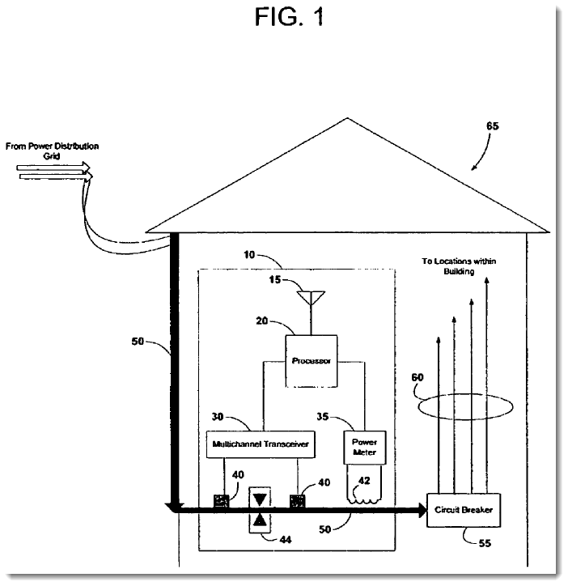
APPX0427.
The ’524 Patent’s disclosure of then-known power line transmission protocols, X-10 and HomePlug, were only known at the time for use on an internal power line network. The ’524 Patent additionally discloses how the consumption data can be encapsulated from X.10- and HomePlug-based messages and sent in IP format using a filter to ensure that the IP transmissions can travel on the pre-meter / external power line. Specifically, the ’524 patent discloses a system whereby the power meter module 364, Homeplug module 352, X-10 module 362, and IEEE 802.11 module 354 are connected to firewalls 356 and 360, which are intern are connected to TCP/IP module 358:
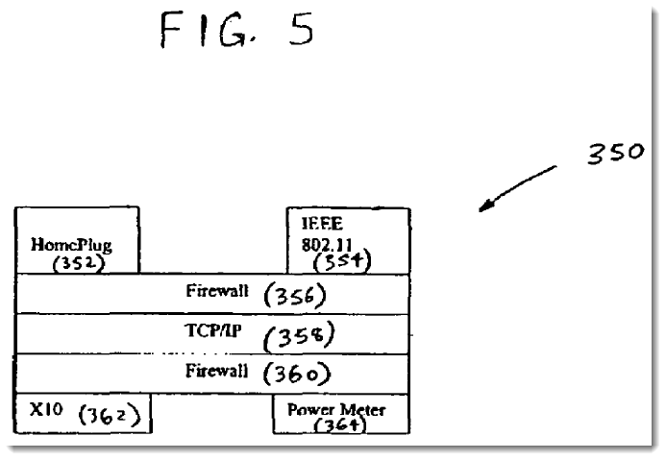
APPX0431, APPX438 (The ’524 Patent, Fig. 5, 8:15-49). According to the disclosure, the configuration of the modules, firewalls, and TCP/IP module allows conversion of the HomePlug, X-10, power consumption, and 802.11 data into IP-based communications. APPX0432-0434, APPX0438-0439 (The ’524 Patent, FIGS. 6 – 8, 8:49 – 9:33).
B. The Sole Cited Reference - Suh
The only instituted ground for invalidity was obviousness over Suh. APPX0196.
i. Suh
The Board summarizes Suh as describing “[a]n [I]nternet ready electronic power meter with automatic reporting capabilities, the electronic power meter recording electrical power usage and other utility usage, and periodically transmitting utility usage reports to a remote site using [I]nternet and conventional protocols of the public or private computer network.” APPX0012 (citing Suh, ¶8, APPX0916). Further in its summary, the Board emphasizes that “Suh’s meter ‘includes the communication components necessary to communicate by telephone line, power line or wireless communication systems to periodically transfer collected data to a remote site.’” APPX0013 (emphasis in Final Written Decision). The board then further emphasized that Suh teaches that its power meter can “include a modem ‘connected to the international computer network 70 via communication lines 72, powerline 73 using developed data transmission overlay technologies or, using a transceiver 74 via airway transmissions through an antenna 76.” Id. (citing Suh, ¶30, APPX0917) (emphasis in Final Written Decision). There is no explanation in Suh of what “developed data transmission overlay technologies” comprise, and the only enabled description of connection between the power meter of Suh and the “remote site” consists of either a dial-up modem pool or a wireless antenna. APPX0918 (¶¶ 34-38).
D. The IPR Proceeding
In its Final Written Decision, the Board concluded that claims 17-22 were obvious over Suh. APPX0047. Relevant findings and conclusions of the Board are detailed below.
- The Board And the Parties Agree on the Definition of Pre- and Post-Metered Power Line as it relates to the “external power line” limitation
Before reaching the question of obviousness, the Board construed a single, uncontested claim limitation—“autonomously.” APPX0009-0010. This claim construction had no bearing on the proceeding, but highlights that the Board failed to construe the entire limitation at issue: “transmitting autonomously in IP format over an external power line network.” APPX0010 (“We determine that no other term [other than ‘autonomously’] requires express construction for this Final Written Decision.”). The Board did, however, apply the definition for “external” that was essentially agreed upon by the parties: “Suh also teaches that the transmission is over an external network as the Internet is external to (i.e., on the distribution grid side of) the meter and dwelling.” APPX0021. However, the Board made no effort to construe the entire limitation, including an “external power line network.”
Despite this important acquiescence, the Board improperly analyzed the limitations at issue, using separate, incompatible portions of the disclosure to support its Decision piecemeal, rather than addressing the limitation as a whole. APPX0020 (“We address below how Suh teaches combining the relevant features of its embodiments to teach transmitting the IP-based power consumption information, where (i) the power consumption information is in IP format, (ii) the transmission occurs automonously, and (iii) the transmission is over an external power line network.”) (emphasis in original). However, “[i]t is the claim limitation, as a whole, that must be considered in claim construction.” Anchor Wall Sys. v. Rockwood Retaining Walls, 340 F.3d 1298, 1311 (Fed. Cir. 2003).
- The Board Found that Suh Teaches IP Format Separately from the Entire Limitation
Faced with no disclosure of IP formatted data over an external power line network, the Board addressed IP formatted data for transmission on an external network separately from “external power line.” APPX0022 (“[W]e find that Suh teaches “transmitting the IP-based power consumption information from the processor to a destination…in IP format over an external…network.” This recitation of the limitation omits “autonomously” and that the external network is ‘power line,’ which we address below. Id. (emphasis added). While both Dr. Akl and Mr. Blackburn confirmed that Suh discloses sending power consumption information in IP format, the Board failed to consider both where the IP conversion occurs, and even if a power line modem is disclosed, whether such a modem is capable of communicating IP formatted information on an external power line network.
iii. The Board Confuses the Enablement of the ’524 Patent with the Enablement of Suh.
The Board attempts to distinguish Patent Owner’s position that Suh was not enabled based on its prospective use of “developed data transmission overlay technologies,” but fails. The Board focuses on the fact that HomePlug was developed before the ’524 Patent, rather than before Suh. APPX0035 (“[T]he evidence of record shows that at least two power line protocols already were developed before the invention of the ’524 Patent.”). This statement misses the point entirely. Petitioner and the Board rely on Suh for teaching external power line transmission, but HomePlug was not publicly disclosed until after Suh. Suh was filed on April 13, 2001. APPX0910. The HomePlug specification, however was not published until December 1, 2001, more than seven months later. APPX0971. Additionally, the Board cites numerous cases for the proposition that a prior art patent is presumed enabled, but Suh is not a prior art patent—it is an abandoned patent application. APPX0034. The Board seemingly takes great pleasure in pointing out that the Patent Owner “does not acknowledge this presumption,” but Patent Owner’s failure to acknowledge the applicability of a rebuttable presumption is for a very salient reason – the presumption does not apply. Even so, patent owner did rebut the presumption, regardless of the characterization of the prior art as patent or non-patent. To meet its burden, Patent Owner provided argument and expert testimony rebutting same. This Court has clarified that the presumption of enablement can be so rebutted with argument alone. In re Morsa 713 F.3d 104, 110 (Fed. Cir. 2013). Therefore, one of ordinary skill in the art could not have read Suh as adopting HomePlug as a then developed data transmission overlay technology, but rather a later-developed data transmission overlay technology.
V. SUMMARY OF THE ARGUMENT
The Board erred by holding that Petitioner met its burden of proving, by a preponderance of the evidence, that a person of ordinary skill in the art “POSITA” would have found claims 17 – 22 of the ’524 Patent obvious over Suh. In doing so, the Board improperly addressed the disputed claim limitation of “transmitting IP-based consumption data autonomously in IP format over an external power line.” While consistently crediting Petitioner’s expert, Dr. Akl, for his uncorroborated testimony, the Board cited a lack of corroboration on the part of Mr. Blackburn, despite neither expert being challenged on their qualifications or methodology.
In arriving at its conclusion of obviousness, the Board committed several errors:
- The Board assumed Dr. Akl’s uncorroborated testimony that a power line modem could be substituted for a telephone modem and still operate as Suh disclosed was correct;
- The Board relied on HomePlug and X.10 as protocols to show that Suh was both enabled and that it would have been obvious to use either to arrive at claim 17, though X.10 is not an IP protocol, and HomePlug was not disclosed before Suh’s application date, and therefore cannot support Petitioner’s argument that both are “developed data transmission overlay technologies” in support of Suh;
- The PTO considered similar references (Roos and Desling) cited by Petitioners (Exhibits 1013, 1014, APPX1119 – APPX1134), and allowed the ’524 Patent, despite both disclosing a “power line modem.”; and
- Suh is not enabled, and, as a patent application, rather than an issued patent, is not entitled to the same presumption of enablement. Even so, Patent Owner did rebut the presumption of enablement. See Morsa, 713 F.3d at 110.
VI. ARGUMENT
A. Standard of Review
This Court’s reviews the Board’s IPR decisions to ensure that they are not “arbitrary, capricious, an abuse of discretion, . . . otherwise not in accordance with law . . . [or] unsupported by substantial evidence.” 5 U.S.C. § 706(2)(A), (E); and see Pride Mobility Prods. Corp. v. Permobil, Inc., 818 F.3d 1307, 1313 (Fed. Cir. 2016). Conclusions of law are reviewed de novo, Belkin Int’l, Inc. v. Kappos, 696 F.3d 1379, 1381 (Fed. Cir. 2012), while findings of fact are reviewed for substantial evidence. See In re Gartside, 203 F.3d 1305, 1315-16 (Fed. Cir. 2000). A finding is supported by substantial evidence only if a reasonable mind might accept the evidence to support the finding. Consol. Edison Co. v. NLRB, 305 U.S. 197, 229 (1938).
In accordance with the above standards, the Board’s ultimate determination of obviousness is reviewed de novo with any underlying factual determinations being reviewed for substantial evidence. Gartside, 203 F.3d at 1312. These factual determinations include (1) the scope and content of the prior art; (2) the differences between the claims and the prior art; (3) the level of ordinary skill in the art; and (4) objective evidence of nonobviousness. Graham, 383 U.S. at 17-18. “[W]hether there is a reason to combine prior art references is [also] a question of fact.” Kinetic Concepts,
Inc. v. Smith & Nephew, Inc., 688 F.3d 1342, 1367 (Fed. Cir. 2012). On these factual components of the inquiry, the Court must “ask[] ‘whether a reasonable fact finder could have arrived at the agency’s decision,’” which “requires examination of the ‘record as a whole, taking into account evidence that both justifies and detracts from an agency’s decision.’” Intelligent Bio-Systems, Inc. v. Illumina Cambridge Ltd., 821 F.3d 1359, 1366 (Fed. Cir. 2016) (quoting Gartside, 203 F.3d at 1312).
Claim constructions by the Board are likewise reviewed in accordance with above standards: underlying factual determinations concerning extrinsic evidence are reviewed for substantial evidence while determinations regarding evidence “intrinsic to the patent” and the ultimate construction of the claim are reviewed de novo. Teva Pharmaceuticals U.S.A., Inc. v. Sandoz, Inc., 135 S. Ct. 831, 841-842 (2015).
B. Dr. Akl’s “Substitution” Argument Fails
The Board’s holding relied almost exclusively on Dr. Akl’s unsupported and uncorroborated testimony that a power line modem could be substituted for the telephone modem of Suh to affect external Internet communications from the modem to a remote site:
In the email messaging system disclosed in Figure 4 of Suh, the lowest layer discloses an embodiment that uses a telephone modem. However, a [person having ordinary skill in the art] would have understood that the patentees intended that any of the suggested physical layer communication networks, including a power line communications modem, could be substituted into Figure 4 without altering any other steps of that Figures. That is, the system would still communicate power measurement data over a TCP/IP connection, but that connection would be carried over a power line rather than a phone line.
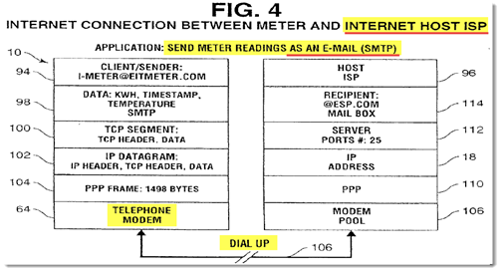
APPX28 (citing Akl Declaration, ¶ 156, APPX 0791). Figure 4 of Suh is shown below:
APPX0913. According to Dr. Akl, the power line modem at the time of the invention would have simply substituted in at (64), and then somehow established a Point-to-Point connection at (110). Dr. Akl provides no basis for this bald assertion, such as how the power line modem would establish such a connection in a grid that was capable of sending an SMTP email from a random dwelling sending a message. Rather, Fig. 4 requires the establishment of the dedicated point-to-point connection between the meter and the host. “Since each client/sender has a telephone number identifying the modem, two-way messages can be sent via the dial-up line 106.” APPX0918 (Suh, ¶ 38). In contrast, the ’524 Patent discloses routing technology, which is required for a non-point-to-point connection, such as a power distribution grid: “the computer 24 contains routing functionality to selectively route and filter the information between a wireless or wired network and the power line, or between sub-networks on the power line.” APPX0436 (The ’524 Patent, 4:58-61). The one-to-one exchange proposed by Dr. Akl fails, because the power line “grid” as the term is used by the Board, is not based on a point-to-point connection, as required by the telephone modem disclosed by Suh. See APPX0021.
Patent Owner does not dispute that Suh could have included data transmission over internal power lines. In fact, Suh supports such an internal configuration, which is entirely consistent with Mr. Blackburn’s testimony that the modem of Suh could be a power line modem, albeit connected on the post-meter side (internal power line) of the dwelling. APPX0027.
Specifically, Suh discloses that not only can signals be carried over power line 73, but also that Suh’s Fig. 1 shows the power line 24 is connected to a battery charger chip 84. Blackburn then makes the uncontroverted statement that “[a] POSITA would know that you cannot connect current consuming devices to the “pre”-metered external power line network (this would be stealing unmetered power from the utility). So, this connection would be made to the “post”-metered existing home electrical wiring (internal powerline) and therefore this communication over power line 73 would not be communicating over an external power line network.” APPX1228 (Blackburn Decl. ¶51). This power line 24 with conducting wires 73 is precisely the disclosure in Suh that the Board seized upon in declaring that Suh disclosed transmission over an external power line.
Suh’s complete disclosure, together with the uncontroverted testimony of Mr. Blackburn, teaches, at best, an internal power line communication to a modem, that then makes a point-to-point connection to the host ISP. See § VI.B., supra. To support its decision, however, the Board inexplicably adds “so that,” and “[that can be]” to the disclosure of Suh, supplying without any prompt the very teaching that Suh is lacking:
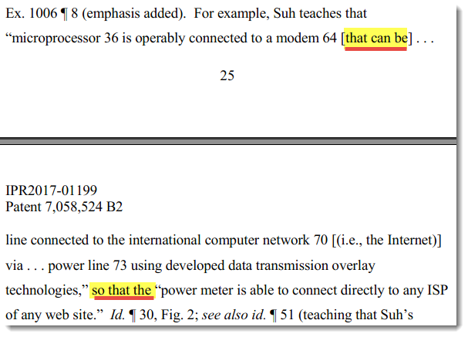
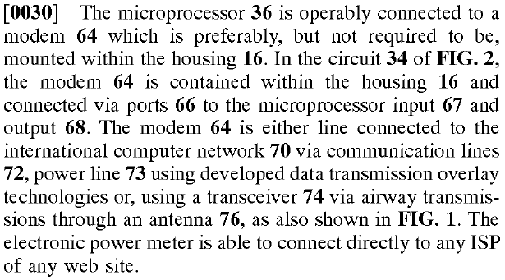
APPX0025-0026. But Suh does not include the “that can be” or “so that” language supplied by the Board:

APPX947 (Suh, ¶ 30).
Thus, while signals may be directed to a power line modem on the internal side of the dwelling, there is no disclosure by Suh that any such modem can use “developed data transmission overlay technologies” to route communications from the modem over the external power lines to a destination.
C. The Board’s Reliance on HomePlug and X.10 as “Developed Data Transmission Overlay Technologies” is Misplaced.
The Board, in an effort to discount Patent Owner’s argument that Developed Data Transmission Overlay Technologies “DDTOT” suitable for “transmitting [IP-based consumption information] autonomously in IP format over an external power line network,” states that Patent Owner’s argument is erroneous, because HomePlug was known prior to the application of the ’524 patent. While true, the Board’s rationale is not sound. DDTOT was disclosed by Suh, not the ’524 Patent, so it would have had to exist at the time of Suh’s filing to support its enablement.
Yet when asked specifically if, “[o]ther than what’s disclosed in the ’524 patent, are you aware of any use of home plug or X10 on an external power line?”, Dr. Akl stated that “[t]he information disclosed in the 524 patent is consistent with what one of ordinary skill in the art would know about the X10 and the home plug and is consistent with my knowledge of those protocols.” APPX1340-1341. In other words, despite Suh predating HomePlug, Dr. Akl was not able to provide any example of HomePlug or X10 being used on an external power line.
Yet the Board unsurprisingly ignored this testimony in Patent Owner’s favor. The Board’s opinion makes clear that it had shifted the burden to the Patent Owner to prove that HomePlug and X.10 had not ever been used on external power lines. APPX0038 (“This testimony does not indicate that it was unknown to use HomePlug to communicate on an external power line network before the ’524 Patent.”) (emphasis added). Yet the Board cites no authority that shifts the burden to the Patent Owner to prove this negative proposition. The question asked was very simple – was Petitioner’s expert aware of any use of X.10 or HomePlug on an external power line network. Dr. Akl could not provide any example of any use of any protocol over an external power line network, save for the ’524 patent itself, yet the Board found it appropriate to credit Dr. Akl’s testimony—with no corroboration as to what one of ordinary skill at the time of the invention would or could have known about external power line communication protocols—as supporting Petitioner’s opinion. This acceptance is in stark contrast to the Board’s treatment of Mr. Blackburn’s testimony with respect to his discussion of masks and encryption. APPX0037. This is especially surprising given Mr. Blackburn’s specific experience deigning “smart meters.” APPX1247 (Blackburn Decl., ¶ 5). The Board cites In re Acad. Of Sci. Tech Ctr., 367 F.3d 1359, 1368 (Fed. Cir. 2004) for the proposition that “the Board is entitled to weight the declarations and conclude that the lack of factual corroboration warrants discounting the opinions expressed in the declarations.”). APPX0037. Rather than hold Petitioner to its burden of showing obviousness, much less requiring corroboration of Dr. Akl’s testimony, the Board discredited the Patent Owner for failing to prove a negative.
D. Suh Had Less Disclosure of Power Line Modems than Prior Art of Record
Petitioner placed Roos (U.S. Patent No. 5,699,276), APPX1119-1130, and Delsing (“The IP-Meter, Design Concept and Example Implementation of an Internet Enabled Power Line Quality Meter,” Jerker Delsing, et al. (IEEE 2000)) APPX1131-1134 in the record as prior art. Both of these references were considered, and both were cited by the examiner during the prosecution of the ’524 Patent.
Under the same standard applicable by the Board, the examiner held that the “power line modem” technology disclosed by these references failed to disclose transmission over an external power line. Specifically, despite Roos stating that the meter is connected to via house interface 374 via the house’s internal wiring. APPX1127 (Roos, 6:39-46). Similarly, Delsing discloses as one of its communications media, “power line modem.” APPX1131 (Fig. 1). Yet despite these references, neither disclosed communication via an external power line network, and unlike Suh which does not disclose any power line modem at all, the Board merely supplied the missing device despite significant evidence contradicting the operability of such a configuration. C.f. KSR, 550 U.S. at 416 (recognizing where the claimed elements are purportedly known in the prior art, there must still be a finding that one of ordinary skill in the art could have combined the elements to arrive at the recited subject matter).
E. The Board did not Explain Why the Person of Ordinary Skill Would Have Considered the Teachings of the Cited References.
Because the Board’s IPR decisions cannot be “arbitrary, capricious, an abuse of discretion, . . . otherwise not in accordance with law . . . [or] unsupported by substantial evidence,” 5 U.S.C. § 706(2)(A), (E), it is important that the Board explain its reasoning for reaching a decision. Synopsys, Inc. v. Mentor Graphics Corp., 814 F.3d 1309, 1322 (Fed. Cir. 2016) (To “allow effective judicial review, . . . the agency is obligated to ‘provide an administrative record showing the evidence on which the findings are based, accompanied by the agency’s reasoning in reaching its conclusions.’”) (quoting In re Lee, 277 F.3d 1338, 1342 (Fed. Cir. 2002)); and see Lee, 277 F.3d at 1342 (“For judicial review to be meaningfully achieved within these strictures, the agency tribunal must present a full and reasoned explanation of its decision. The agency tribunal must set forth its findings and the grounds thereof, as supported by the agency record, and explain its application of the law to the found facts.”). Insofar as the Board’s present decision fails to adequately explain why a person having ordinary skill in the art would look to the teachings of Suh combined with either HomePlug or X.10, that decision is inadequate.
Under the obviousness theory presented by Petitioner, it was not sufficient for the Board to find that Suh, supported by the admitted prior art of HomePlug or X.10 suggested all of the elements of the ’524 patent claims at issue. See In re Kotzab, 217 F.3d 1365, 1371 (Fed. Cir. 2000) (explaining that a finding of obviousness “cannot be predicated on the mere identification in [the prior art] of individual components of claimed limitations”). The Board had to further find that a person of ordinary skill in the art would have been motivated to combine the prior art (or substitute components within the same reference) in the way claimed by the ’524 patent claims at issue and that such an individual would have had a reasonable expectation of success in doing so. KSR, 550 U.S. at 418-19 (“because inventions in most, if not all, instances rely upon building blocks long since uncovered, and claimed discoveries almost of necessity will be combinations of what, in some sense, is already known”; “it can be important to identify a reason that would have prompted a person of ordinary skill in the relevant field to combine the elements in the way the claimed new invention does.”); and see In re NuVasive, Inc., 842 F.3d 1376, 1381-82 (Fed. Cir. 2016) (reversing a finding of obviousness where the Board provided only conclusory statements that a POSITA would have been motivated to combine the prior art references); In re Warsaw Orthopedic, Inc., 832 F.3d 1327, 1333-34 (Fed. Cir. 2016); Ariosa Diagnostics v. Verinata Health, Inc., 805 F.3d 1359, 1364-67 (Fed. Cir. 2015). As part of that inquiry, the Board needed to examine whether Petitioner’s proffered prior art reference was even properly considered in the context of the ’524 Patent. Indeed,
the obviousness analysis [is not] an inquiry into whether a person of skill, with two (and only two) references sitting on the table in front of him, would have been motivated to combine (or, in [Petitioner’s] view, could have combined) the references in a way that renders the claimed invention obvious. The real question is whether that skilled artisan would have plucked one reference out of the sea of prior art [] and combined it with [another] to address some need present in the field []. Whether a skilled artisan would be motivated to make a combination includes whether he would select particular references in order to combine their elements.
WBIP, LLC v. Kohler Co., 829 F. 3d 1317, 1337 (Fed. Cir. 2016). “To facilitate review, this analysis should [have been] made explicit.” KSR, 550 U.S. at 418.
In this case, the Board ignored the fact that HomePlug did not exist at the time of the application of Suh, and pressed forward by stating that HomePlug was a “developed data transmission overlay technology” that existed, rather than it was prospective. Furthermore, the Board ignored Dr. Akl’s admission that the only teaching he was aware of that even made use of HomePlug or X.10 for external power line transmission was the ’524 patent itself. APPX1340-1341.
The Board’s discussion presupposes that a POSITA, once presented with the cited references, would have understood that they could be combined. This is not enough; such reasoning does not imply a motivation to pick out those references and combine them – especially when HomePlug did not represent DDTOT at the time of Suh’s filing. See Belden Inc. v. Berk-Tek LLC, 805 F.3d 1064, 1073 (Fed. Cir. 2015) (“[O]bviousness concerns whether a skilled artisan not only could have made but would have been motivated to make the combinations or modifications of prior art to arrive at the claimed invention.”); InTouch Techs., Inc. v. VGO Communications, Inc., 751 F.3d 1327, 1352 (Fed. Cir. 2014).
The Board seems to have assumed that because HomePlug was being used in Petitioner’s proposed obviousness argument, it was appropriate to simply look to the asserted combination of HomePlug with Suh. APPX022-024. As such, the Board examined the teachings of the references and the assumed a motivation to combine. Where the Board failed, however, was in not first assessing whether the person of ordinary skill “would have plucked [Suh] out of the sea of prior art” at all. WBIP, LLC., 829 F. 3d at 1337. As such, there are gaps in the Board’s analysis and these gaps are reason enough alone for the Court to reverse the Board’s decision. See, e.g., In re Van Os, 844 F.3d 1359, 1362 (Fed. Cir. 2017) (Newman, J., concurring-in-part, dissenting-in-part); accord Icon Health and Fitness, Inc. v. Strava, Inc., No. 2016-1475, slip op. at 23-24 (Fed. Cir. Feb. 27, 2017) (O’Malley, J., concurring-in-part, dissenting-in-part).
VII. CONCLUSION
For at least the forgoing reasons, the Board’s decision finding claims 17-22 of the ’524 Patent unpatentable should be reversed, or at least vacated and the case remanded for further determinations consistent with the correct application of the burden of proof, the appropriate consideration of Petitioner’s expert’s admissions regarding the sole novelty of teachings of the ’524 Patent’s use of external power line network communication, and the prohibition of using hindsight to invalidate claims.

